**Experiment No :** 06

**Name of the Experiment :** Verification of Maximum Power Transfer Theorem.

**Objective:**

* To verify the Maximum Power Transfer Theorem experimentally by determining the load resistance at which the maximum power is delivered in an electrical circuit.
* To measure and compare the power delivered to the load resistor at various resistance values to identify the condition for maximum power transfer.
* To gain practical experience in constructing electrical circuits and using measuring instruments such as voltmeters and ammeters effectively.
* To understand the practical application of the Maximum Power Transfer Theorem in optimizing the design and analysis of electrical circuits.

**Theory:**

The Maximum Power Transfer Theorem states that maximum power is delivered to a load when the load resistance ( RL) matches the internal resistance ( RS ) of the source. The power ( P ) delivered to the load is given by:

$$P=\frac{V^{2}}{{\left(R_{s}+R_{L}\right)}^{2}}×R_{L}$$

Maximum power transfer occurs when:

$$R_{L}=R_{S}$$

This principle is essential for optimizing power delivery in circuits. In this experiment, the theorem is verified by varying the load resistance and observing that maximum power is achieved when RL = RS .

**Apparatus:**

* Ammeter ( 1 pieces; 0-5A )
* Voltmeter ( 1 pieces, 0-450V )
* Multimeter ( 1 pieces )
* Resistor ( 3 pieces; 370 Ω, 108Ω, 37Ω )
* AC voltage source (220V, 50Hz)
* Connecting wires

**Circuit Diagram:**

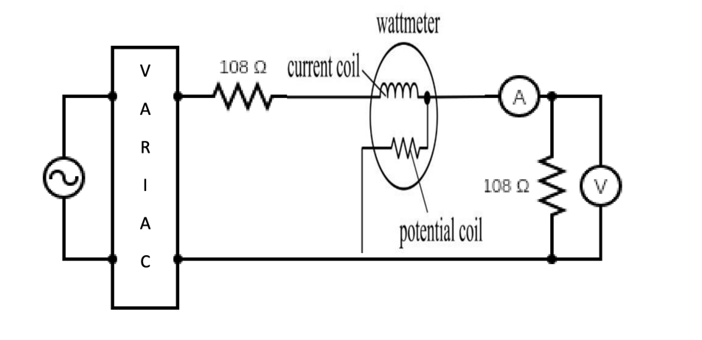

108 Ω

108 Ω

VARIAC

Figure-01: Electric Circuit

**Data Table:**

|  |  |  |  |  |  |
| --- | --- | --- | --- | --- | --- |
| **SL no.** | **Thevenin’s Resistance,**  **Rth (**Ω **)** | **Load Current,**  **i( A )** | **Load Voltage, v1**  **( V )** | **Load Resistance,**  **RL (**Ω **)** | **Load Power, P**  **( W )** |
| 1 | 70 | 1.55 | 45 | 29.03 | 70 |
| 2 | 1.30 | 62.40 | 48 | 82 |
| 3 | 1.20 | 71.8 | 29.83 | 85 |
| 4 | 1.10 | 79.10 | 71.90 | 86 |
| 5 | 0.95 | 88.60 | 84.17 | 85 |
| 6 | 0.85 | 96.70 | 113.76 | 82 |

**Graph :**

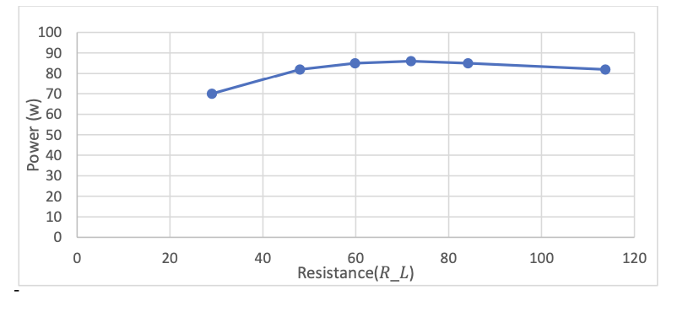

**Result:**

The load resistance 𝑅𝐿 at which maximum power is transferred is approximately equal to the internal resistance 𝑅Th of the source, as per the Maximum Power Transfer Theorem.

**Conclusion:**

The experiment confirmed the Maximum Power Transfer Theorem. It showed that the load received maximum power when ( RL ) was approximately equal to ( RTh ). This aligns with the theoretical prediction.